Supplementary 1
Identification of knockout mice
primer
  1540 | Mir21-tF2 | CTTACTTCTCTGTGTGATTTCTGTG | -94bp=451bp Wt=545bp
  1541 | Mir21-tR2 | ACAACCTTTCCAAAATCCATGAGGC | -94bp=451bp Wt=545bp
PCR  system
  Reaction Components | Volume （μL）
  gDNA Template | 2.0
  10×Taq Buffer(mg²⁺ plus) | 2.0
  dNTP Mixture（10 mM） | 0.5
  Primer mix（10 μM） | 0.5
  Taq DNA polymerase(5 U/µL) | 0.5
  Milli-Q H₂O | To 20μL
PCR process | P1
  Seg. | Temp. | Time | Cycle
  1 | 95ºC | 5min
  2 | 95 ºC | 30s
  3 | 58ºC | 30s
  4 | 72 ºC | 45s | 2-4,40
  5 | 72 ºC | 3min
  6 | 25 ºC | hold
Gel concentration | 1.5%
Electrophoregram | 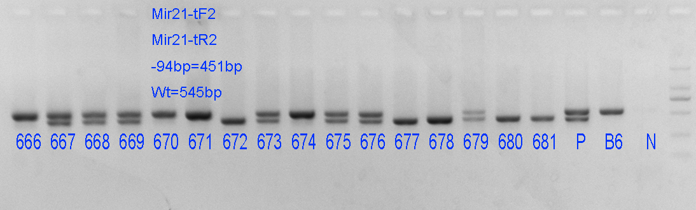
Result judgement | -94bp/-94bp：672，677，678，680，681  -94bp/wt：667, 668, 669，673，675，676，679  Wt/wt：666, 670, 671, 674

